**Website Planning**

In this website, I am trying to help Chin Community of Nelson create a community website that allowed the community members to visit and see what is happening in the community. I have a friend who told me about the chin community from Myanmar who lived here since 2003, they don’t have any internet related sites where they can check news and others, so I want to introduce them to the digital world and help them by creating a website for them to check the local news from the community leaders such as Sports, Celebration, Wedding etc…

**Plan 1**

My first plan for this project is to meet the Chin community leaders and ask them if it’s alright for me to create a website for their community. If they said yes, I want to know what types of website they want, how they want it (like multiple device friendly meaning they can open using multiple devices) and finally when they want the website to be publish to the publics.

**Plan 2**

My second plan for this project is to do research about community websites, just to get an inspiration of the website structure for the chin community. Since this is my first-time planning, designing and programming the website I need to do a lot of research about websites and other types, styles and functionality in websites. After this I will start designing the website by drawing or by using the words to create a design version of the page and show it to the stakeholders and see what they think about the design.

**Plan 3**

My last plan for this project is to start the programming, I will be using notepad++ to start my html coding. First I will start with a draft version of the web and after I will show the stakeholders what the websites will look like, and if they give me more information I will add more. I will be start working on the programming as soon as I finish the design and a meeting with the stakeholders.

**REVIEW OF THE TASK**

*This assessment requires website that supports and enhances a local* business in this case I am supporting and enhancing the chin community here in Nelson.

*The website includes HTML, CSS, Scripting (Java, C++ etc…) and available on multiple devices.* I will be creating the website using Note++, where the text is HTML, CSS and JavaScript to make it greater in design.

*The task also said to include multiple media types e.g. text, web languages, animation, still images etc.* I will be asking and use the photos from the Facebook only after when there is an agreement from the community leaders for me to used their photos. I will be using photos and videos provided by the Chin Community of Nelson.

**RESEARCH**

In my first research, I look at websites to see the structure of a community website and how it is layout. I found three websites from the local, that look good for a community to use and I like the design of these websites. However, since this is an original work therefore I have to create every from the beginning using only my work so I decided to start working on the design.

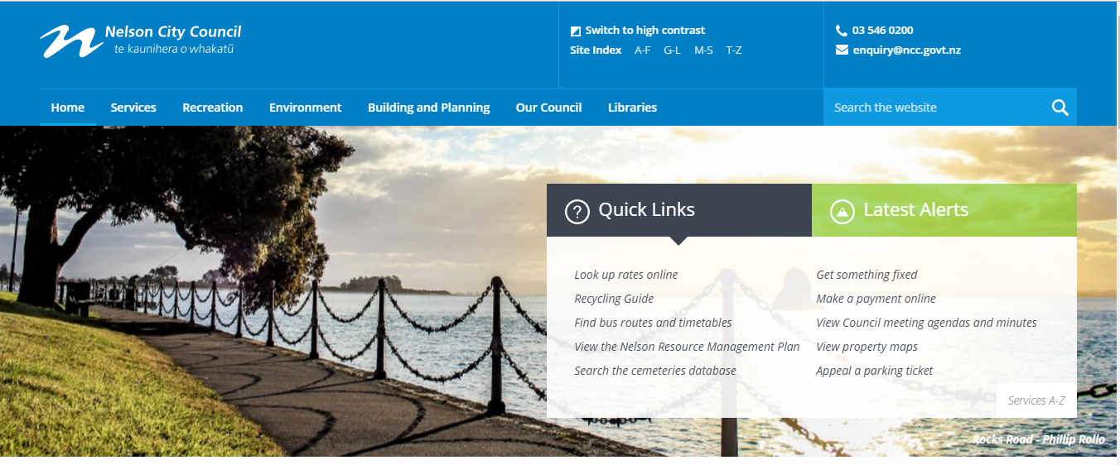

<http://nelson.govt.nz/>

Comments:

The first website I’ve came across is the Nelson City Council website. I open this websites because the council websites is a very popular website here in Nelson and basically everyone can go on and see what happening in Nelson.

I really like the design of how they put the contact information at the (Header). It make it easier for the people to get the information faster.

But I am not quite sure having too much popup message like the ***Quick Links*** and ***Latest Alerts*** I think its just confuse the visitors.

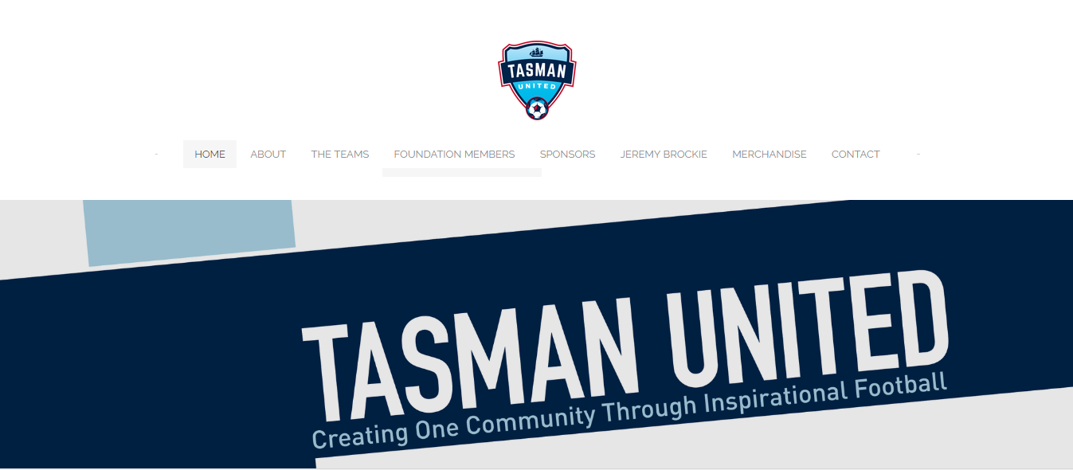

<http://www.tasmanunited.nz/>

Comments;

The Tasman united is Nelson Football team formed this year. I went to their websites since they just started the websites and they have a small numbers of members in the football community. The number of members are similar to the Chin Community, therefore it’s a suitable design model to get the inspiration.

The design of this websites is clear and easy for the web visitor to use it. However, the font design and the color of the fonts in the Navigation bar is quite bad. It’s very hard to read and the color doesn’t match with the back ground color.

In my website I will be using color that stand out to make it easier for the users.

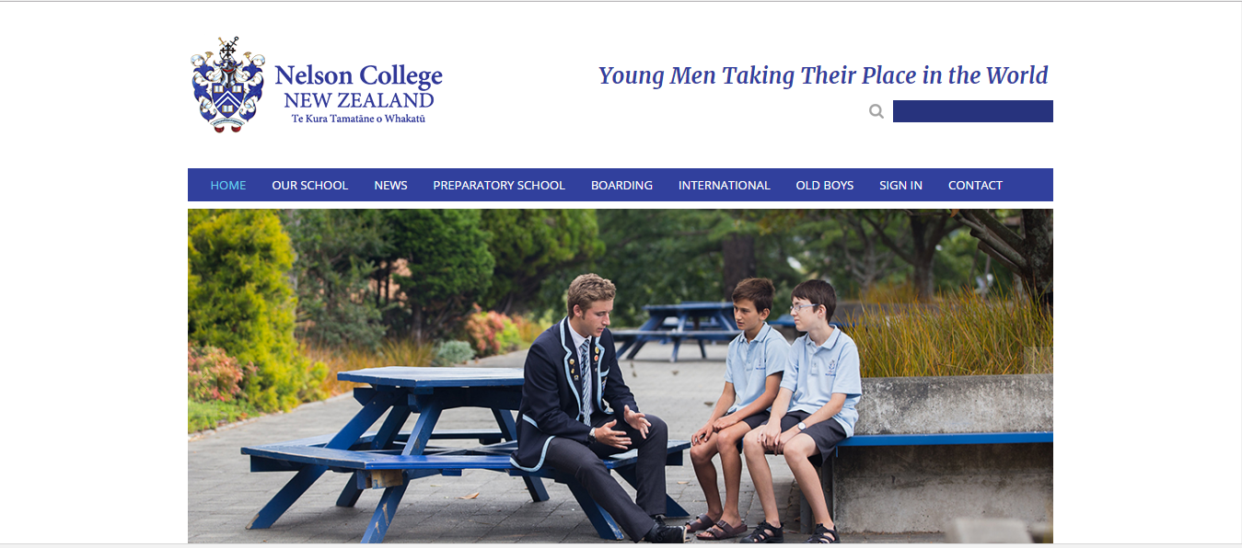

http://www.nelsoncollege.school.nz/

My last research is the Nelson college school website. Nelson College is a community where parents uses the website to see news about the school and their kid’s reports. It’s a great example of a great community website.

I really like the idea of displaying an image in the top (header) to show what the website is about. I think Nelson College website design is little too old fashion. The website is simple, and it’s quite messy, the **search bar** and the logo, they are pretty much taking too much space in the heading area.

**Conclusion of the research**

Based on the information I gather around from the exemplars, I want to make a website that standout outs to the users. For example the colour choice, the font style and other properties.

I will have a plan of the website that I am creating. But before I stated the plan I will be meeting with the Chin Community Leaders who are the stakeholders and ask them about what they want to see on the website and how they want it. This meeting will take place in a formal way , I will be writing down all the information they give me.

I planned to see the community leaders 21/10/2016 at 3:15pm after school. I will be meeting with one of the community leader (Name) and he is the President of the chin Community.

**Meeting with the stakeholders**

I had a meeting with the stakeholders (community leaders) about the website, they are quite happy when I tell them about my project. We had a good discussions about the website, the give me some ideas about, and I started asking what they want the website to do. They told me about their community yearly events and how they want to put the show it on the web. They also want a page where they can upload news for the community members to view. I writes down all the information on a paper for future reference and at the end we come to an agreement with the community president.

**Contact**

**Logo**

Navigation Bar

**Header (Slideshow)**

Footer

**About**

**Photo**

**Photo**

**Photo**

The logo will be located here in the middle of the page. The logo will be provided by the chin community.

Contact

Logo

This is the navigation bar where all the buttons for the other pages are located. The buttons will be the same colour with the background colour(like this ) only the words will standout . And when user hoover over the buttons the colour will change. The font style for this will be Bold, Italic. The size of the fonts is uncertain, because I haven’t seen what its gonna look like having a large font size.

Button

Button

Button

Button

In here I will put the contact information of the community for people to see it easier and more faster.

**Photo**

**Photo**

**Photo**

**Slideshow: In this area I will display a single photo slideshow. Make it friendlier and show the activities that happened in the past. The photo will be provided by the chin community.**

Contact

Logo

Navigation Bar

Here are the photos that will display next after 5 second on the slideshow.

**About**

Footer

In here I will put a paragraph about the Nelson Chin community. The font type will be Calibri (body) and the font style will be Italic, size around 12 to 15. The colour will be black or white (uncertain)

Like usual, I will put the footer here down in the button. I will put little information like a Facebook link or other email link and also the date if this website published. Font type Calibri(body) , Font colour Black and the size will be around 11 to 12.

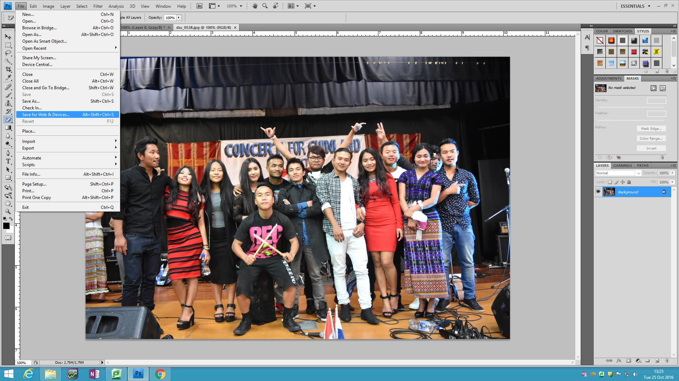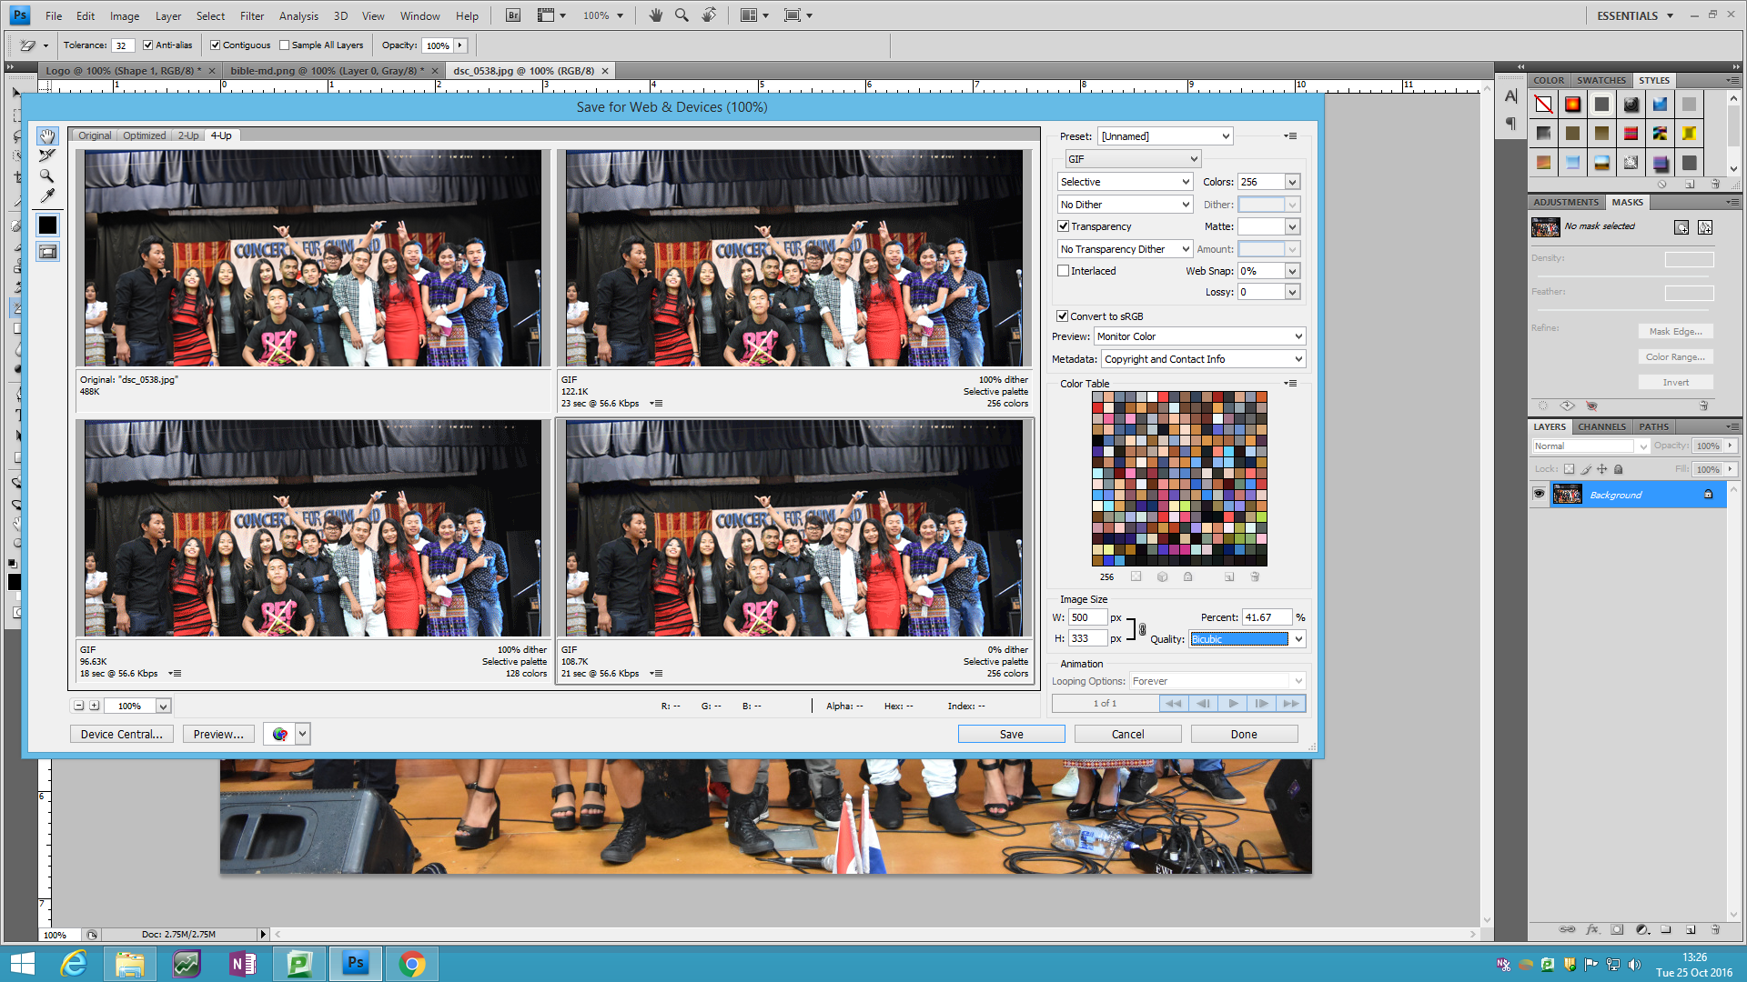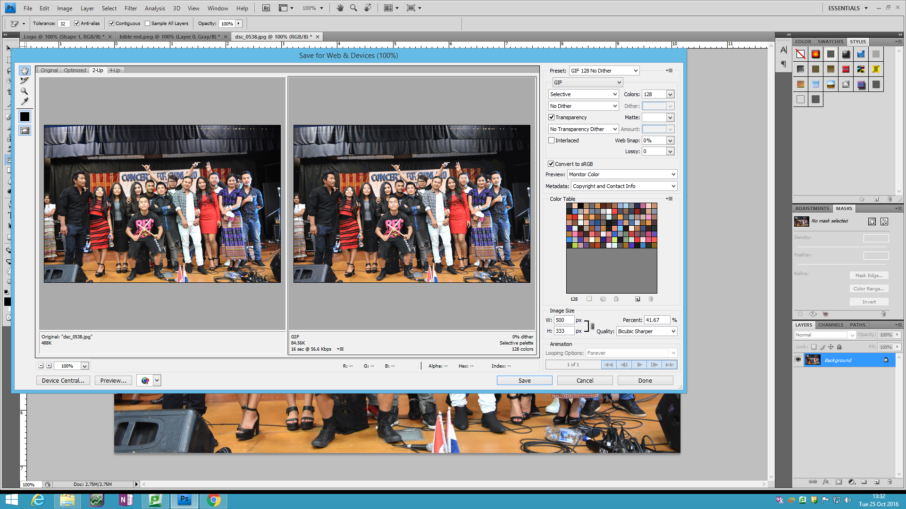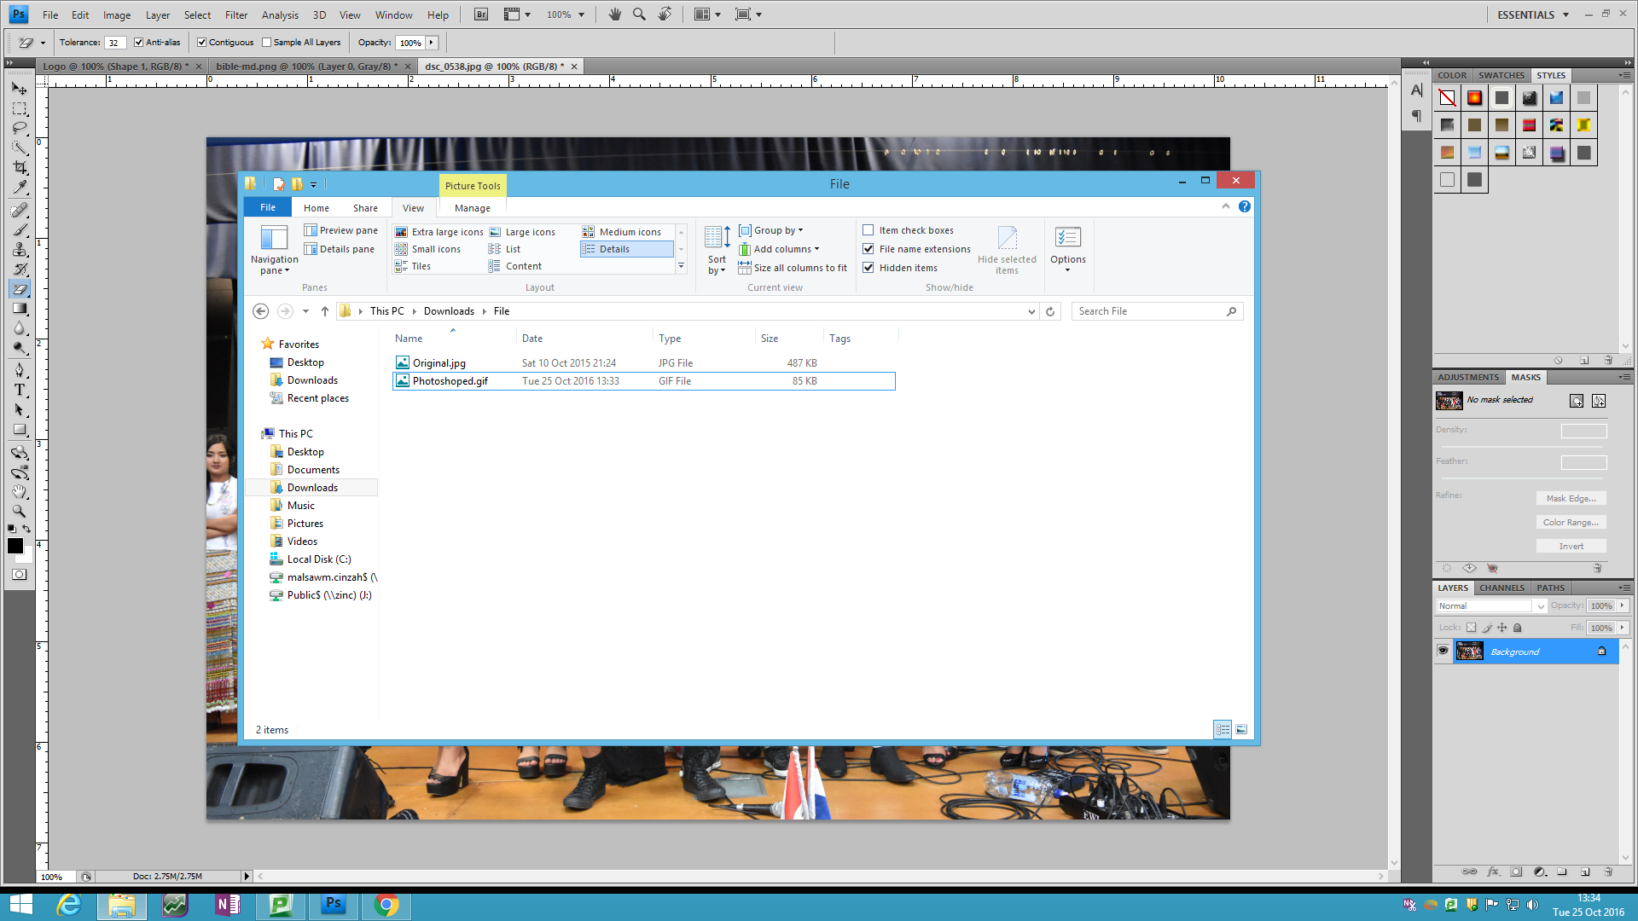

This is me using the Photoshop software to change the image file size and actual size. I change the file size because when I used the original photo, it’s too big, and it takes time for the website to load, if the internet connection is not fast. Also the photo size is too big and when I used it took a lot of space.

Changing the file size and the image size. I went to file then Save to Web and design.

This is what showed up when I wish to see the photo in four different size. The first one is the original one, Send one is lower file size and the last one is the smallest file size. The smallest file size is quite bad with the quality, because I am compressing the size, the pixels are bigger and it’s not a good quality.

This is the two compression between the original photo and the compressed one. As you can see the size of the image are quite different. I will save and using the compressed one later in the website.

As you can see here, this is the difference in the file after the compression. I used tool to avoid losing too much quality of the photo.

***Independence with regard to decision making in the selection of software and application of complex tools, techniques and testing procedures***

**Software:** I used notepad ++ because it’s what the school computers has, and it is much easier for me to run the software. I’ve used Notepad++ in the past therefore have experience using it.

I used Photoshop to edit the images that I am using in the website, Photoshop Software is one of the best photo editing software, it has a lot of tools, such as the texture, drawing pen etc… I used Photoshop because I know how to use it since I have a little bit of experience during year 12.

I used Microsoft Words to write my reports. Microsoft Words is another great software to edit and publish texts. I’ve been using it for a while and with some experience I can do my work good compare to other software’s.

***Legal, ethical and moral responsibilities***

The Website is based on original content. There are no copyright and/or trademarked materials of any kind will not be used in the website. All the photos that I used are provided by The Chin Community.

**Testing Schedule**

My Testing plan will be as following:

1. Check for any broken links or images.
2. Make sure slideshow works 100% of the time.
3. Test website on multiple browser e.g. Internet Explorer, Google Chrome, Firefox, Opera, and make sure everything is working as planned and design is in acceptable condition.

|  |  |  |
| --- | --- | --- |
| **What’s being tested** | **How it’s being tested** | **Results/outcomes** |
| Links | By clicking every link and button on the website and making sure that the social buttons open in a new tab, as well as open the correct Facebook or Instagram page. | The Links initially opened in the same page which can be frustrating for the user, therefore I added the “target=’_blank’” to each of the social links to open them in a new tab, which is more user friendly. |
| Images (gallery) | Checking the gallery page and making sure all the images are displaying properly and making sure that the images resize or zoom on hover. | The images resized too slowly therefore I have sped the transition up from 0.5s to 0.2s, also the scale resize is 150% instead of 200% which covered too large of an area of the webpage and caused difficulty in navigating out of the image. |
| JavaScript code (slideshow) | By controlling and timing each slide fade and making sure all the pictures display every cycle. | After checking the slideshow worked correctly, I changed its slide period from 5000ms to 3500ms to let the viewer see more photos in the homepage. But the slideshow was already working as intended. |
| Multiple Platform Compatibility |  |  |
|  |  |  |